“An Appeal to All Pediatricians and Members of Indian Academy of Pediatrics”
Date: October 18, 2012
Dear All,
As you know, a mass campaign (Supplementary Immunization Activity (SIA) to provide second dose of Measles vaccine is underway in some states and about to begin in some other states of the country, to vaccinate children in the age group of 9 months to 10 years old. It is our utmost duty to support this activity by encouraging parents of eligible children to participate in these campaigns.
We need to offer our clinics/ hospitals/ nursing homes, or other facility to function as “Adverse Event Following Immunization (AEFI) management site/centre” in case any serious AEFI is encountered during the campaign. Furthermore, we need to fully support and cooperate with the local health authorities to counteract any misinformation against these campaigns.
Who is eligible to receive Measles vaccine in these campaigns?
-All children in the age group of 9 months to 10 years irrespective of their earlier immunization status;
-Even those children who have documentation of receiving one dose of Measles at 9 months and/or MMR at 15 and/or again at 4-6 years MUST also be offered this vaccine!!
-There is no harm of giving even an extra dose (i.e. third dose) of Measles/Measles-containing vaccine;
What is the rationale for second dose measles containing vaccine (MCV2)?
-With 70% routine Measles vaccination coverage and 85% vaccine effectiveness with a single dose given at 9 months of age, real protection to Measles is only 60% (0.70 × 0.85=0.60)
-Thus approximately 40% of India’s annual birth cohort of 27 million children remains susceptible to Measles
- At this rate, the accumulation of susceptible children in successive annual birth cohorts would reach the epidemic threshold level every 2-3 years
-The rationale for providing a second opportunity for Measles vaccination is two-fold:
- Immunological rationale: To immunize the primary vaccine failures; those children who failed to respond to the first dose;
- Programmatic rationale: To vaccinate those children who were missed by routine services for first dose of Measles in Routine Immunization;
-Most children who have failed to respond to the first dose of MCV respond well to a second dose.
-MCV2 can be delivered either through existing routine services (i.e. RI) or through Measles catch-up immunization campaigns, the choice is determined by the status of MCV1 coverage;
- States with MCV1 coverage <80%: Second opportunity for Measles vaccine through measles catch-up campaigns in 9 months - 10 years age (planned SIAs in 14 states);
- States with MCV1 coverage >80% MCV2 through Routine Immunization (RI) at 16-24 months of age (MCV2 in RI of 21 states)

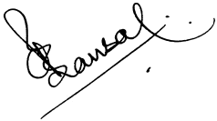
Dr. Rohit Agrawal Dr. C. P. Bansal
President, IAP President Elect, IAP

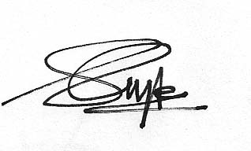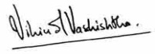
Dr. Sailesh Gupta Dr. Vipin M. Vashishtha
Hon Secretary General Convener, IAP COI

